**Experiment Name**

Write a program to (a) Display a “?”, (b) read two decimal digits whose sum is less than 10, (c) display them and their sum on the next line.

**Theory**

As assembly language instructions are so basic, Input/output is much harder in assembly language than high level languages. DOS functions are used to take I/O. In assembly language there are operation field, operand field, variables and they work with different registers. There are ADD,SUB,DEC,INC instructions available in assembly language for adding, subtracting, Decrement and increment respectively. For input and output, MOV AH,1 and MOV AH,2 are used respectively in assembly language.

**Code:**

.MODEL SMALL

.STACK 100H

.CODE

MAIN PROC

MOV AH,2

MOV DL,'?' ;for displaying “?”

INT 21H

MOV AH,1 ;for 1st input

INT 21H

MOV BL,AL

MOV AH,1 ;for 2nd input

INT 21H

ADD AL,BL

MOV BL,AL

SUB BL,48

MOV AH,2 ;for display the output

MOV DL,0DH

INT 21H

MOV DL,0AH

INT 21H

MOV DL,BL

INT 21H

MOV AH,4CH ;for DOS exiting

INT 21H

MAIN ENDP

END MAIN

**Output:**

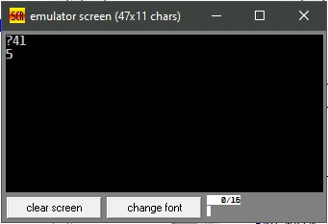

**Discussion:**

In this above code, firstly MOV AH,2 was used to show a output. To show “?” in the output MOV DL,’?’ was used. Then MOV AH,1 was used twice to take two integers as input whose sum is not greater than 10. After that, ADD operation was used to add them and SUB operation was used to subtract 48 to convert the character to integer. After that, finally MOV AH,2 was used to show the sum as output of the program.

**Experiment Name**

Write a program to (a) prompt the user, (b) read first, middle and last initials of the name of a person and (c) display them down left margin in lower case.

**Theory**

As assembly language instructions are so basic, Input/output is much harder in assembly language than high level languages. DOS functions are used to take I/O. There are ADD,SUB instructions available in assembly language for adding, subtracting respectively. For input and output, MOV AH,1 and MOV AH,2 are used respectively in assembly language. Variables play the same role in assembly language that they do in high level languages. Each variable has a data type and is assigned a memory address by the program. DB,DW are known as Define Byte variable and Define Word Variable respectively.

**Code:**

.MODEL SMALL

.STACK 100H

.DATA

A DB ?

B DB ?

C DB ?

.CODE

MAIN PROC

MOV AH,1 ;this is for 1st CHARACTER

INT 21H

MOV A,AL

ADD A,32

MOV AH,1 ;this is for 2nd CHARACTER

INT 21H

MOV B,AL

ADD B,32

MOV AH,1 ;this is for 3rd CHARACTER

INT 21H

MOV C,AL

ADD C,32

MOV AH,2

MOV DL,0DH

INT 21H

MOV DL,0AH

INT 21H

MOV DL,A ;this is for retrieving A

INT 21H

MOV AH,2

MOV DL,0DH

INT 21H

MOV DL,0AH

INT 21H

MOV DL,B ;this is for retrieving B

INT 21H

MOV AH,2

MOV DL,0DH

INT 21H

MOV DL,0AH

INT 21H

MOV DL,C ;this is for retrieving C

INT 21H

MOV AH,4CH ;this is for DOS exiting

INT 21H

MAIN ENDP

END MAIN

**Output:**

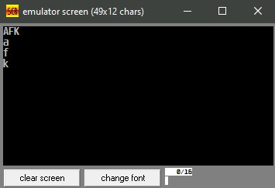

**Discussion**

In this above code, firstly MOV AH,2 was used to show a output. A,B,C was declared as to define Bytes for storing three initials of a person’s first, middle, last name respectively. Then MOV AH,1 was used thrice to take three characters as input. Then 32 was added using ADD operation to convert the character into lowercase. After that, finally MOV AH,2 was used to show the output of the program as it is needed to be. For each new line in the output, these commands was used,

MOV DL,0DH

INT 21H

MOV DL,0AH

.